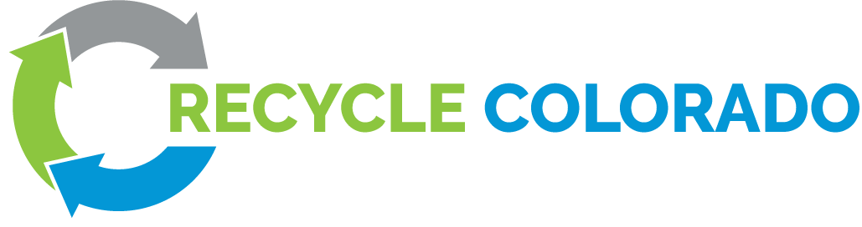

Policy Committee Notes
Thursday, July 13th, 2023
1:30 PM - 2:30 PM MT

Present: (18): Randy Moorman, Clinton Sander, Alicia Archibald, Ameila Kovacs, Brandy Move, Celene Peck-Andreano, Elaa Hink, Gail Garey, Jace Driver, Jonathan Wachtel, Lindsay Stovall, Melik Gorton, Rachel Roussel-Diamond, Rachel Setzke, Suzanne Jones, Wolf Kray, Ally Byzewski, Nicoals Wilson

>> Next meeting: Thursday, September 7th from 1:30 to 2:30 p.m.

Action Items:
- Review the new structure proposal
- Form working groups for 2024 Legislative Priorities: (1) EPR implementation; (2) EPR for batteries (maybe add solar panels); (3) Waste Tire sunset; (4) Improve RREO/Extend RREO
- Working groups meet, conduct research and write one-pager on proposal to present at next Policy Committee Meeting, Sept. 7, 2023 to make recommendation to Board of Directors.

RC Policy Committee Structure and 2024 Strategy
Agenda
Structure Proposal (changes below are from the discussion during the Policy Committee Meeting and were submitted to the Board of Directors for approval)
- Eliminate Sector Reps and in their place:
- Use Google Survey (Forms) as the main communication tool to RC members regarding legislative action. Members respond to the Google Survey with their feedback. Members indicate sector in form.
- DRAFT bills will be disseminated to members as soon as possible to begin conversations of red flags, changes.
- Policy Committee Leadership is charged with reviewing Google Survey results and reaching out to sectors not represented in survey responses. Policy committee shares results of survey with members.
- Sector Round Tables can meet during the session to discuss bills. Sectors will be responsible for forming/organizing their own Round Table (RC staff can announce meetings and schedule Zoom calls):
  - Haulers
  - Local Government
  - Rural (already exists in Rural policy working group)
  - Manufacturers/Producers/Large Generators
  - Compost/Organics (already exists with COCC)
  - Recyclers
  - Consultants
  - Non-Profits
  - Non-Recycling Businesses
  - Landfills
  - Individual members

- ALL members (including multiple members from the same organization) may participate in Policy Committee Meetings.
7. At Policy Committee Meetings policy proposals (i.e. bills) are discussed and survey results reviewed/shared.
- Each member organization may cast ONE vote on policy recommendations to the Board of Directors through the use of SLIDO or another similar technology. Those voting MUST be present at the Policy Committee Meeting to vote. IF a member organization cannot attend the meeting, they may designate a PROXY to vote for them. In order for the PROXY vote to count, the absent organization MUST also submit a written statement to be read by the PROXY explaining their vote.
- Individual members (non-organization) vote individually in a separate vote. The SIMPLE MAJORITY of the individual members vote determines the single vote counted as a Representative vote of the individual members. For example, 20 individual members are present at the Policy Committee meeting. 13 vote in favor of RC supporting Bill X and 7 vote opposed. When the Policy Committee Member Representatives vote on a recommendation for the Board of Directors, a SINGLE vote will be cast in favor, as representative of the individual members group.
Suzanne Jones: Proposal/ Question - One vote per organization instead of designating a specific person. If the company cannot make it then do a proxy vote for the company.
Jonathan Wachtel: Likes Suzanne's recommendation as it would create a little less work for the organizations. Active voting is utilized with slido. We need more proactive soundbytes to get the information we need. Eliza can get draft bills into our hands sooner. We need more than one week's notice. A live ongoing spreadsheet which you can review past, present, future timing on bills.
What is appropriate use of the sector lists? Recycle Colorado sends out a Doodle Poll and manages the sector lists. Reaching out the other sector members can still happen organically.
Do any companies have multiple memberships? No
Amelia Kovacs - On the topic of dissolving the sector rep position - I like how this streamlines this process. As a sector rep, I felt like it was a lot of steps to collect information, so I could see this working really well.
Elizabeth Chapman - After we get the results we share and regroup with anyone who has not participated.
Randy Morrman - We seem to be in agreement for each organization having one vote opposed to a designated person at said organization

2024 Legislative Priorities
- JBC approves EPR Needs Assessment Scenario or run another bill to formalize EPR without JBC.
Volunteers: Rachel, Brandy, Celene, Randy
- EPR for batteries (all batteries)
Volunteers: Melik, Rachel, Brandy, Nick, Jonathan, Liz mauro
- Waste tire sunset -
Volunteers: Nick, Brandy, Alicia
- Improve RREO/Extend RREO
Volunteers: Liz, Alicia, Compost Council, Julie Mach, Monique DiGiorgio, Lauren Kirn

Federal funding activity around battery recycling seems to not be a good place to put our energy. There may be a group anyway.
2 month period then regroup in later September with discussions
RREO. We could run a bill in 2024. 2025 is the last year we could run a bill for RREO.
Jonathan Wachtel: Is there anymore thought for solar panels? Maybe put one working group together for batteries and solar panels.

Non-Legislative Priorities
- Model compost/organics zoning ordinance for local governments
- Compost Contamination
- Research existing end markets for C&D
- Life cycle analysis of Carbon Intensity
- Bottle Bill/DRS study on how it works with EPR

Reconvene next on September 7th. Come ready to vote to submit to the board for approval.

