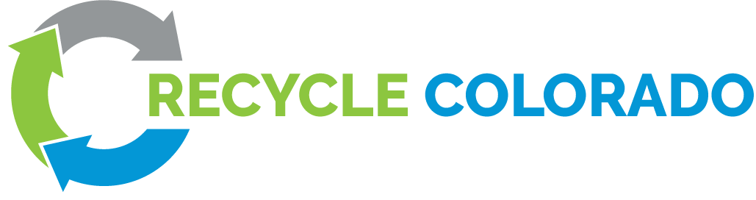

Policy Committee Notes
Thursday, January 5th, 2023
1:30 PM - 2:30 PM MT

Present: (34): Ryan Call, Ally Byzewski, Brandy Moe, Randy Moorman, Jonathan Greenspan, Alicia Archibald, Dan Matsch, Darla Arians, Gail Garey, Jace Driver, Jeanette Hanna, Jeannie Vanderburg, Jennifer Richardson, Jonathan Levy, Jonathan Wachtel, Kris Holstrom, Lauren Kirn, Lindsay Stovall, Mark Petrovich, Megan Lane, Meghan Ibach, Meghan MacKillop, Mellik Gorton, Michael Port, Neil Noble, Nina Waysdorf, Rachel Roussel-Diamond, Rachel Setzke, Robbie Tepperberg, Sarah Jones, Shea Logan, Stacy Katz, Zan Jones, Wolf Kray

>> Next meeting: Thursday, February 2nd from 1:30 to 2:30 p.m.

Action Items:
- Provide feedback to the Organic Waste Diversion Study bill by Friday 1/6
- Reach out to Brandy if you know of a sponsor to help with the Lobby Day (2/7/23) breakfast and lunch.

Link: Recycle Colorado 2023 Legislative Priorities draft 1-4-23.docx

Agenda
- Rural Policy update
  - Rachel Setzke presented on PPRA toolkit.
    - https://ecocycle.org/ppra
    - https://ecocycle.org/ppra-municipalities
    - https://ecocycle.org/ppra-businesses
    - https://ecocycle.org/ppra-communities
  - Next steps on EPR and rural community support. Reviewed and left comments for the Organics Study bill proposal.
  - Congratulations to Gail Garey (Steamboat Springs City Council) for being on the EPR advisory board

- Compost bill updates
  - New feedback deadline extended to Friday Jan 6th. Sending the document to the Recycle Colorado board next week for approval.
  - Discussion
    - Once we have a draft, we will bring it back to Recycle Colorado for feedback before introducing the bill.
    - Stacy Katz: Would also like to see a total GHG assessment, including transportation emissions, other LCA considerations. Concerned with environmental externalities. Many CO landfills already have methane capture technology.
    - Zan: This was a top recommendation from CDPHE’s statewide Organics Mgmt. Plan. It seems like there’s a lot of support within CDPHE to move forward. Could be our biggest “bang for our buck.”
    - Kris Holstrom: Received a grant to look at composting countywide (San Miguel County). Asking for resources on the electrification of collection trucks.
  - Brandy sharing written comments:
    - Bill language should include funding for rural composting sites. Rural transportation costs are a challenge. No unfunded mandates. A landfill ban could increase illegal dumping/burning.
    - Need organics end market development. OMP cites the lack of end markets as a challenge.
    - Don’t do a “ban without a plan.”
    - Yard waste might contain pesticides that contaminate finished compost.
    - Consider upstream food waste solutions to feed people.
    - Tacking yard waste and food waste is too big of a lift.
  - Jonathan W. was asked, Do we need legislation for CDPHE to do a study?
    - Randy: CDPHE could probably do a study without legislation, but if we want the study to include everything we want, we need to legislate. Our successful bills (EPR, Circular Econ. Development Center) came from study bills. Legislation is also more public and educates legislators during the process, laying the groundwork for a better bill.
  - Neil: Haven’t yet received comments in writing, but the study should include specifics on infrastructure solutions. Could there be a new category of facility? How can we include existing private and corporate infrastructure into this process?
  - Kris: Include an inventory of what facilities already exist and their capacity. Is there an opportunity to transition from diesel to electric collection trucks? Concern that transportation GHGs would outweigh savings from composting.
    - Randy: Some of these concerns are addressed in the OMP.
  - Jennifer Richardson: We can expect that the study will show that an organic landfill ban will be good for the environment. What are the “middle pieces” to make it happen?
    - Randy: The intent of the study bill will be to figure out these pieces.
    - Rachel: The study will also look at local and state-level regulations.

- Lobby Day: In-person on Tuesday, February 7th.
  - Brandy: We’ve secured a spot two blocks from the capital for breakfast and training. Looking for funding for breakfast and lunch. Also secured a spot for the reception afterward. Expect a “save the date”
    - If you have a lunch/breakfast sponsor, please let us know. Reach out via email.
  - Randy: We will get started around 7:30 a.m. to train, and get to the capitol by 9:00. Meetings will occur in the morning and afternoon. Reception will be from 4-6PM. You don’t have to stay the whole time, you can sign up for morning, afternoon, or reception, or participate the whole day..

- Setting our 2023 legislative agenda
  - EPR: Expect the PRO to form in the Spring, and expect the Needs Assessment to be completed by the end of the year. The Joint Budget Committee needs to approve the plan in 2024. We need to keep an eye out for any legislation to change or repeal EPR.
  - Circular Economy Center: Applications are open through February.
    - Rachel Roussel-Diamond: Let CDPHE know if you have questions on the application, questions due Friday 1/6/23.
  - Organics diversion:
  - Megan Lane: We haven’t heard much from businesses. Let’s not assume that silence means they’re in agreement.
    - Randy: We will keep trying to get their feedback.

